Height

Definition
# Source: AI Source: Provided by: [Data Path: Persons Table -> ID Column: 1, Name_En Column: Motasem Essam] -> From: [ChatGPT] on [7/20/2026]
In geometry, height is the perpendicular distance from a base, or its supporting line, to the opposite vertex, side, or parallel base.
In simple terms:
Height is the shortest distance measured perpendicular to the chosen base.
$$\boxed{\text{Height}=\text{Perpendicular Distance to the Base}}$$
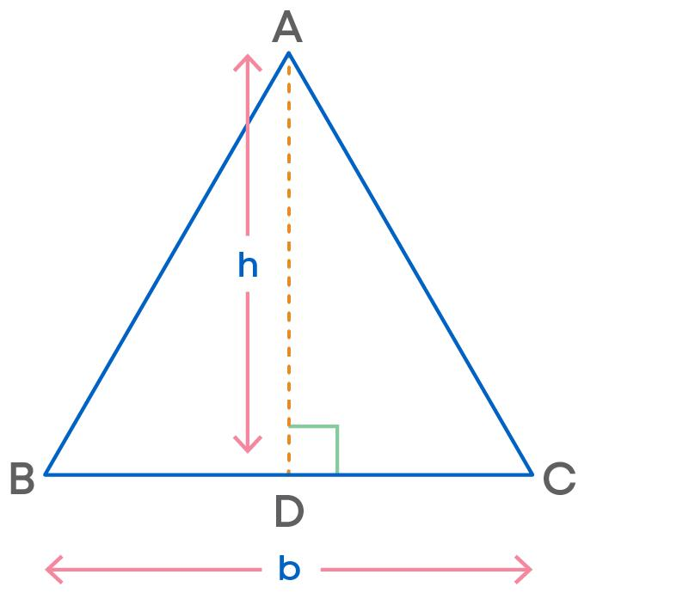
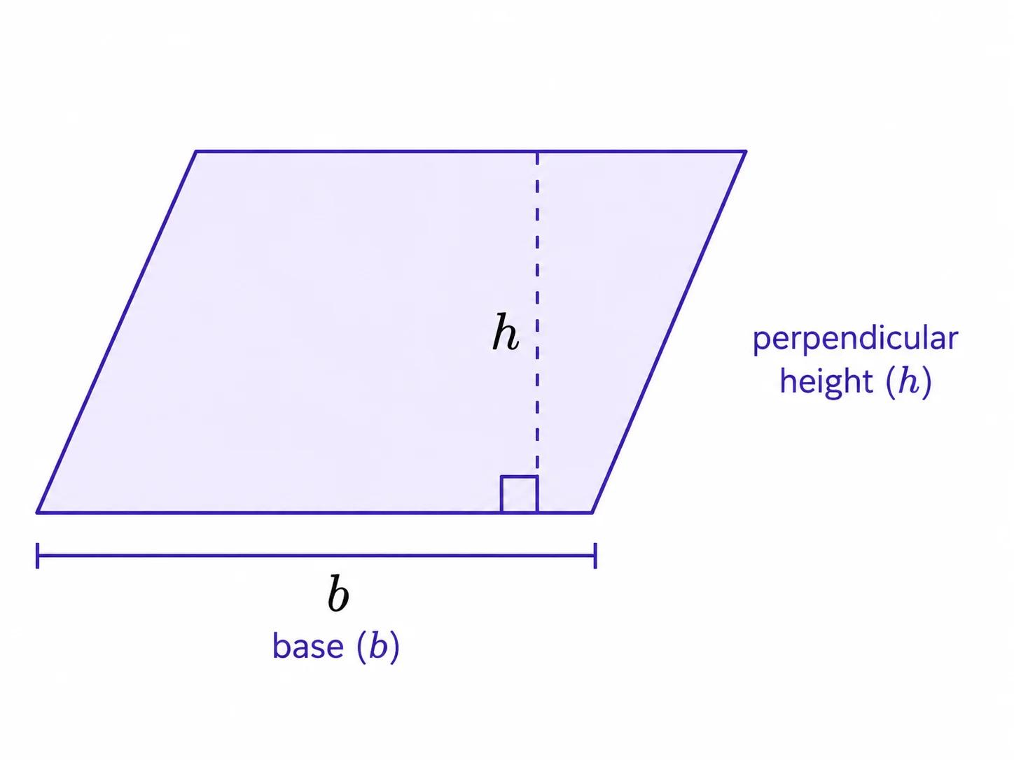
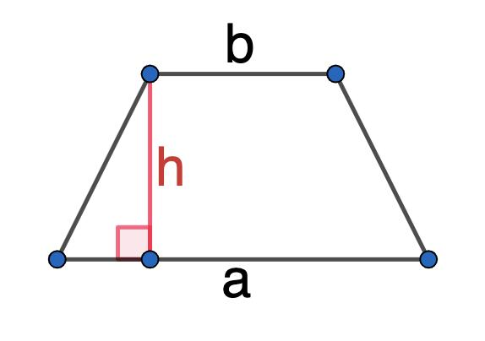
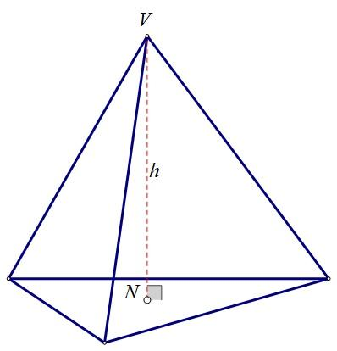

Characteristics
# Source: AI Source: Provided by: [Data Path: Persons Table -> ID Column: 1, Name_En Column: Motasem Essam] -> From: [ChatGPT] on [7/20/2026]
The height:
- Is a distance.
- Is measured perpendicular (90°) to the base.
- Depends on the chosen base.
- Is often represented by $h$.
- Is used extensively in area and volume calculations.
- Is not necessarily the same as a slanted side.
$$\boxed{h⊥b}$$
where $b$ represents the base.

Height in Plane Geometry

1. Triangle
# Source: AI Source: Provided by: [Data Path: Persons Table -> ID Column: 1, Name_En Column: Motasem Essam] -> From: [ChatGPT] on [7/20/2026]
The height of a triangle is the perpendicular distance from a vertex to the line containing the opposite side.
$$\boxed{A=\frac{1}{2}bh}$$
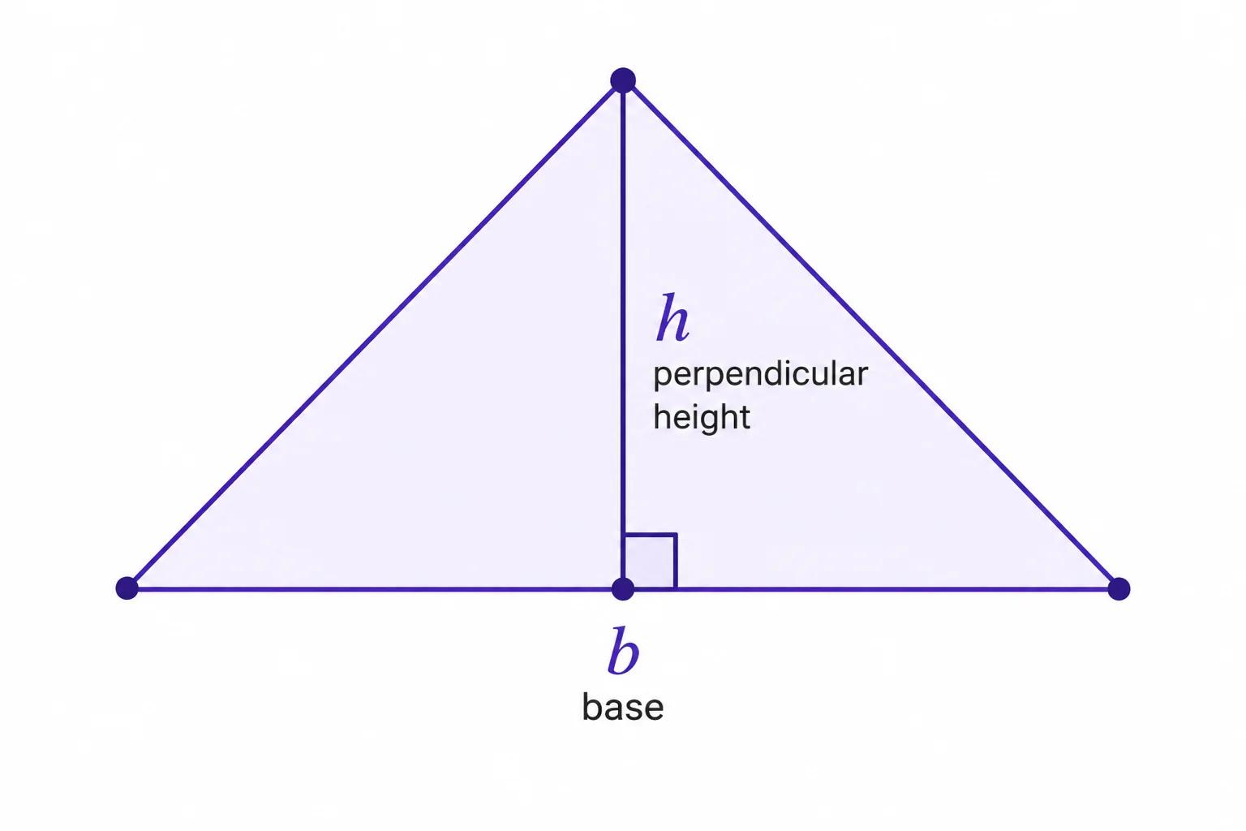
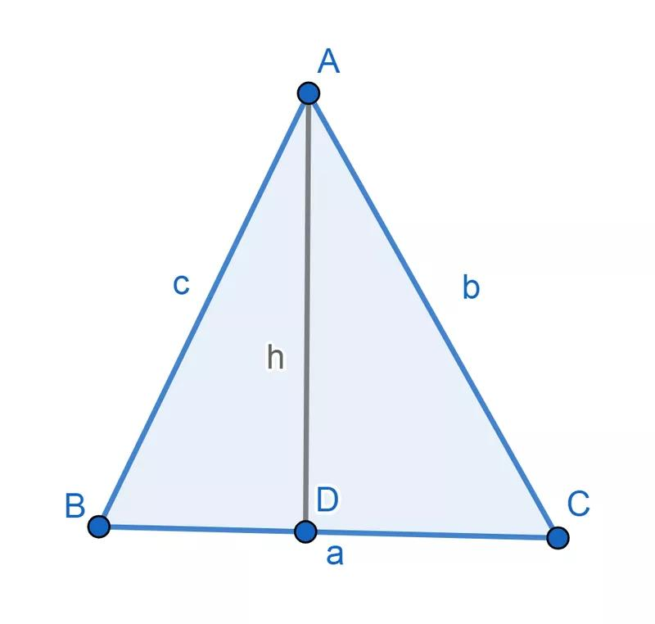
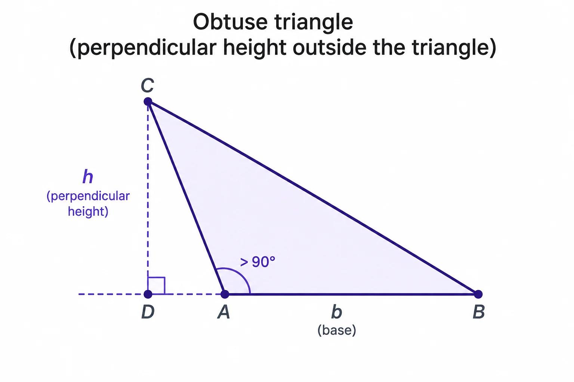
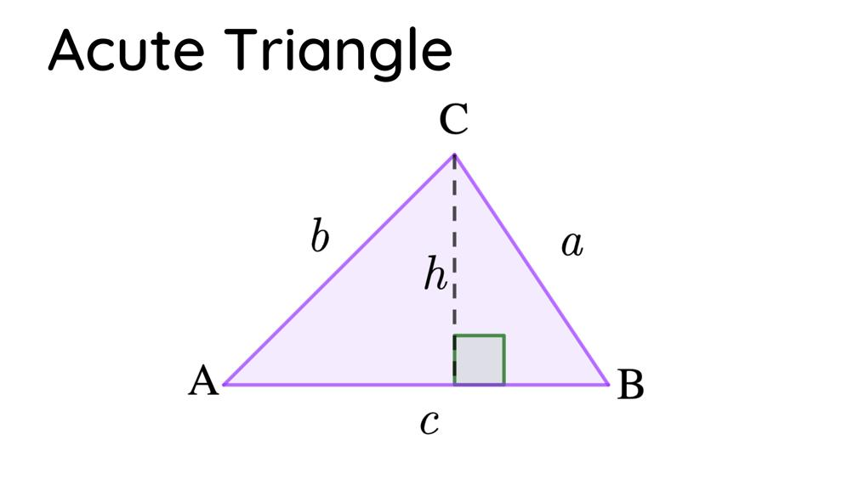
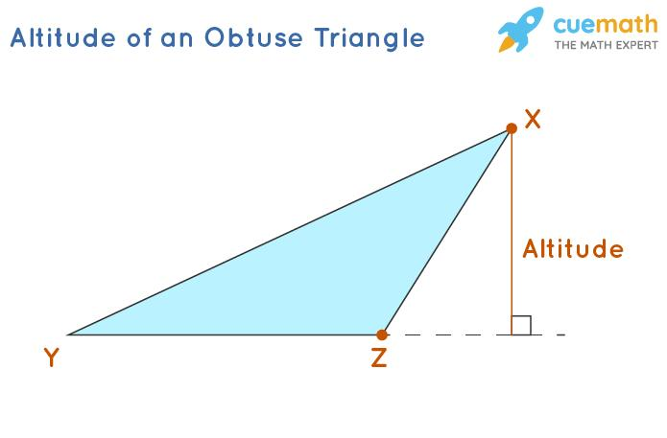
The height is also called an altitude of the triangle.
For an acute triangle, the altitude usually lies inside the triangle.
For an obtuse triangle, the altitude may extend outside the triangle.

2. Parallelogram
# Source: AI Source: Provided by: [Data Path: Persons Table -> ID Column: 1, Name_En Column: Motasem Essam] -> From: [ChatGPT] on [7/20/2026]
The height is the perpendicular distance between the two parallel sides selected as the bases.
$$\boxed{A=bh}$$

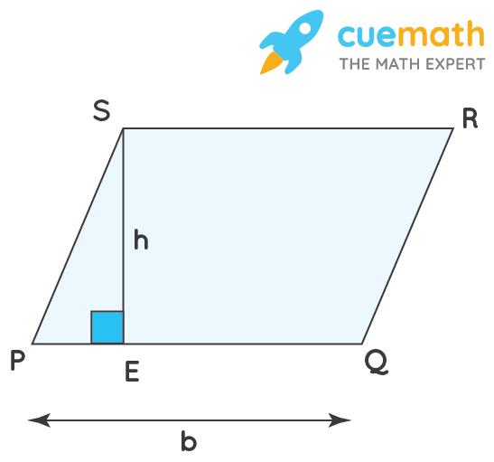
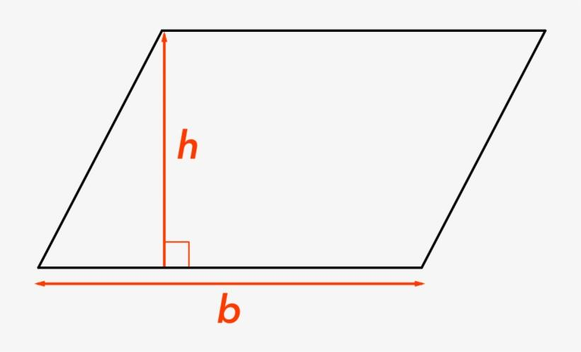
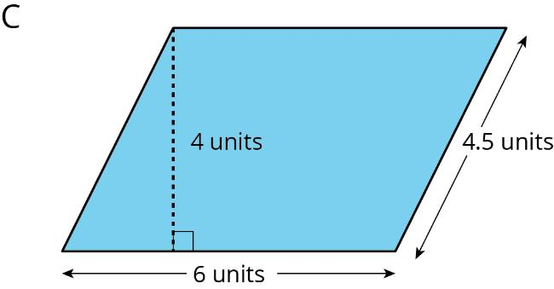
The slanted side is not the height unless it happens to be perpendicular to the base.

3. Trapezoid
# Source: AI Source: Provided by: [Data Path: Persons Table -> ID Column: 1, Name_En Column: Motasem Essam] -> From: [ChatGPT] on [7/20/2026]
The height is the perpendicular distance between the two parallel bases.
$$\boxed{A=\frac{\left(b_{1}+b_{2}\right)h}{2}}$$

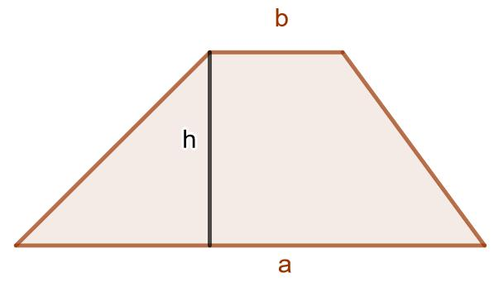
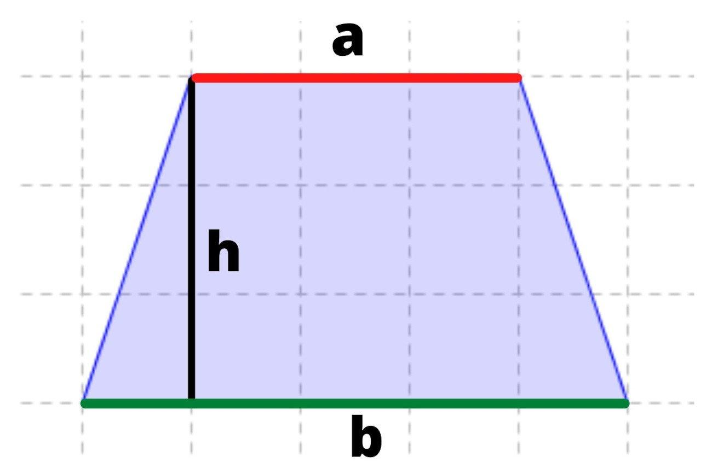
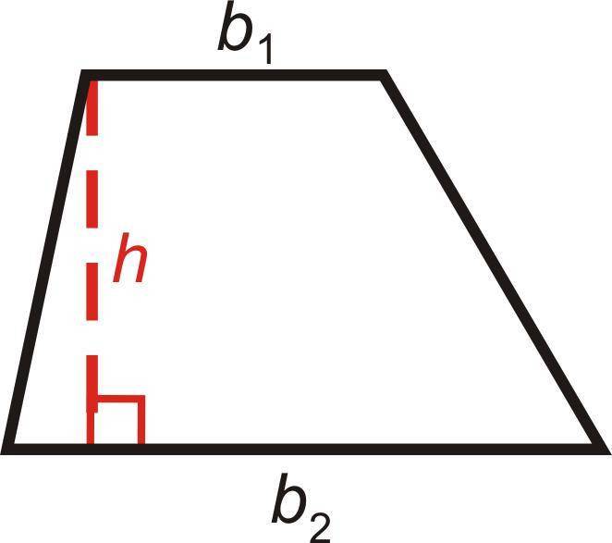

Height in Solid Geometry
For a three-dimensional solid, height is generally the perpendicular distance from the base plane to the corresponding opposite plane, vertex, or surface.

1. Prism
# Source: AI Source: Provided by: [Data Path: Persons Table -> ID Column: 1, Name_En Column: Motasem Essam] -> From: [ChatGPT] on [7/20/2026]
For a prism:
$$\boxed{V=Bh}$$
where:
- $B$ = area of the base
- $h$ = perpendicular height of the prism
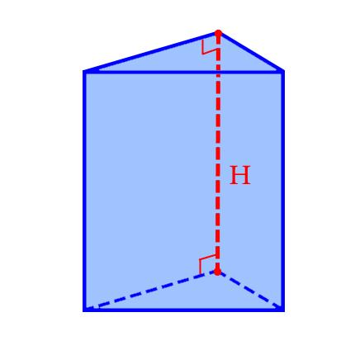
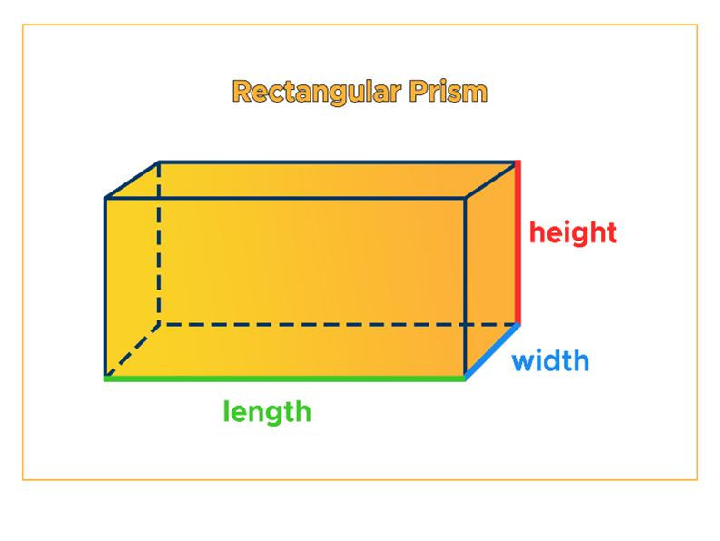
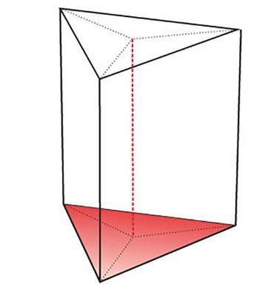
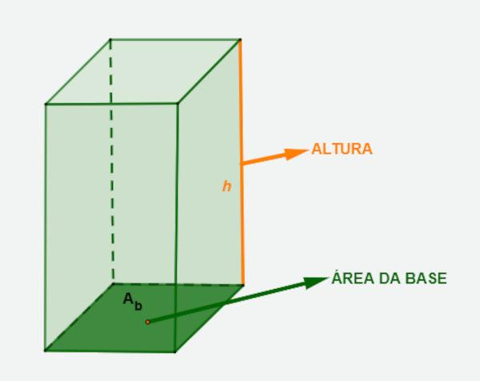
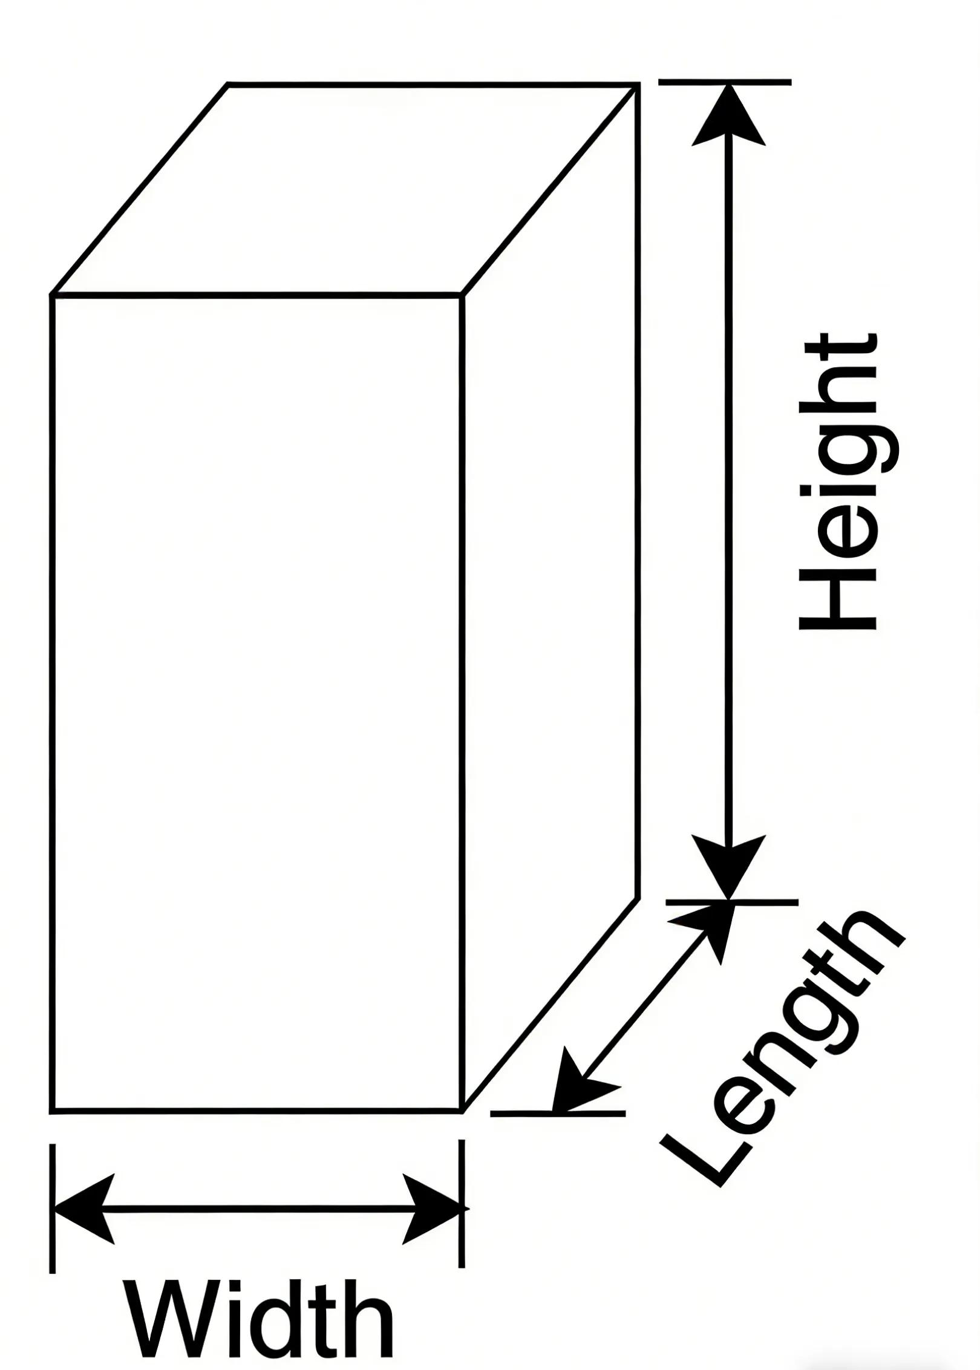
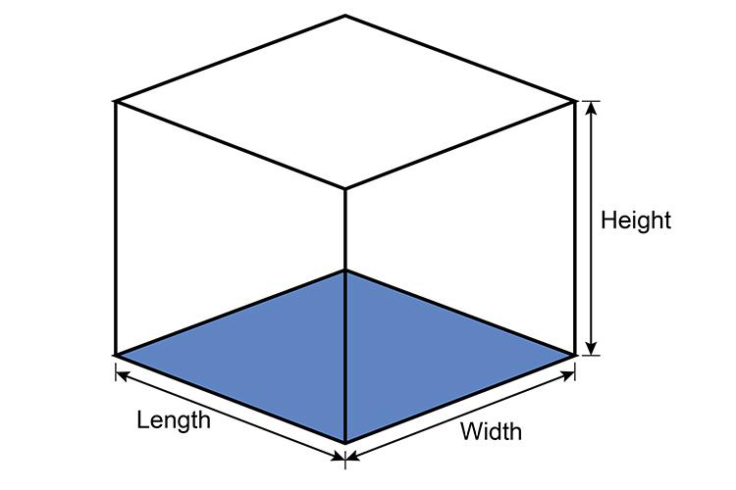

2. Cylinder
# Source: AI Source: Provided by: [Data Path: Persons Table -> ID Column: 1, Name_En Column: Motasem Essam] -> From: [ChatGPT] on [7/20/2026]
The height of a cylinder is the perpendicular distance between its two circular bases.
$$\boxed{V=πr^{2}h}$$
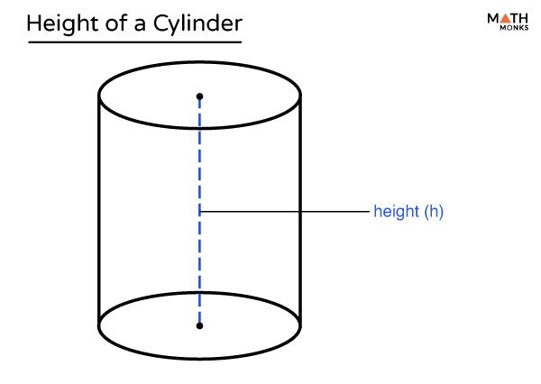
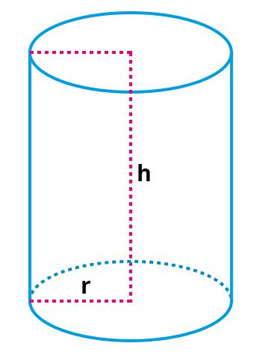
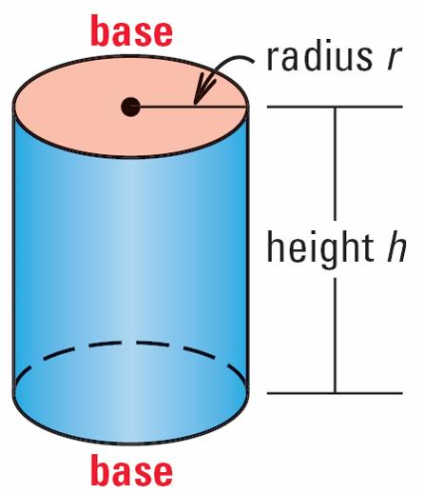
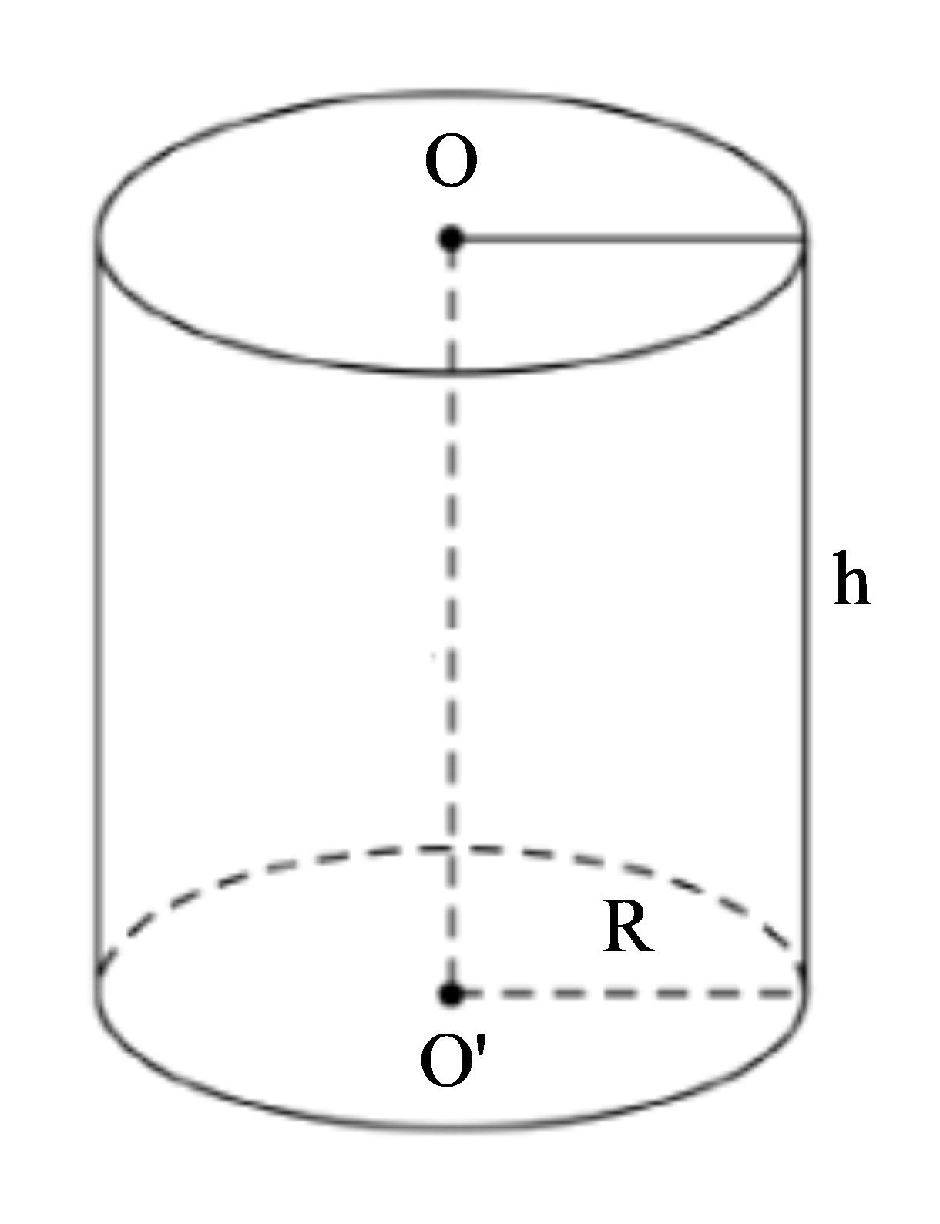
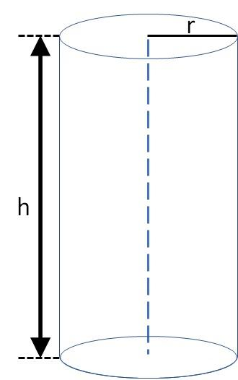

3. Pyramid
# Source: AI Source: Provided by: [Data Path: Persons Table -> ID Column: 1, Name_En Column: Motasem Essam] -> From: [ChatGPT] on [7/20/2026]
The height of a pyramid is the perpendicular distance from the apex to the plane containing the base.
$$\boxed{V=\frac{1}{3}Bh}$$
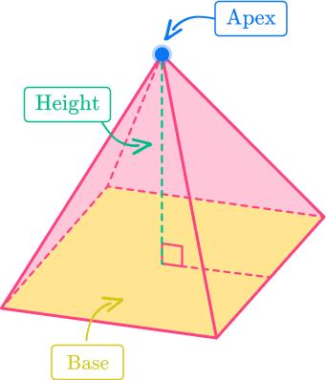
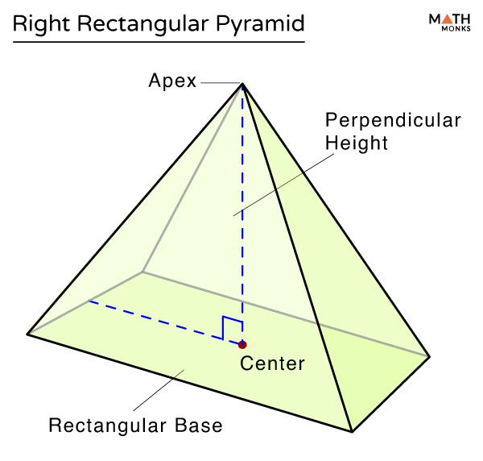
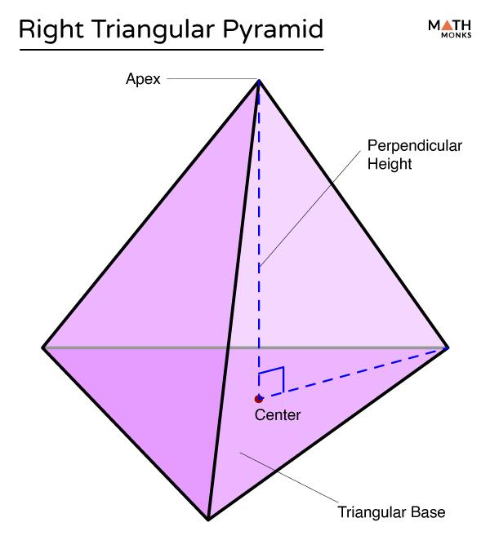
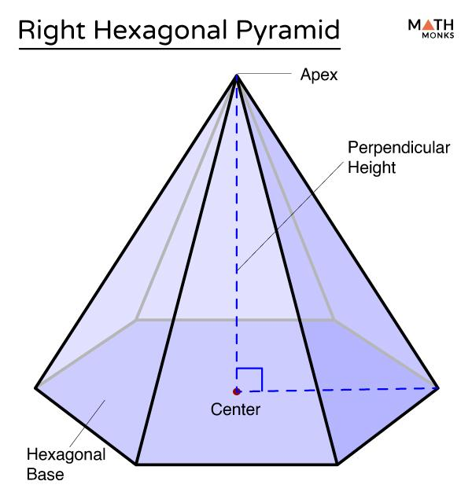
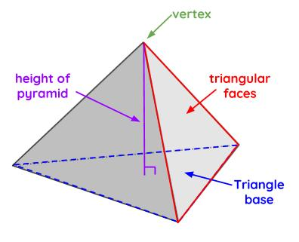
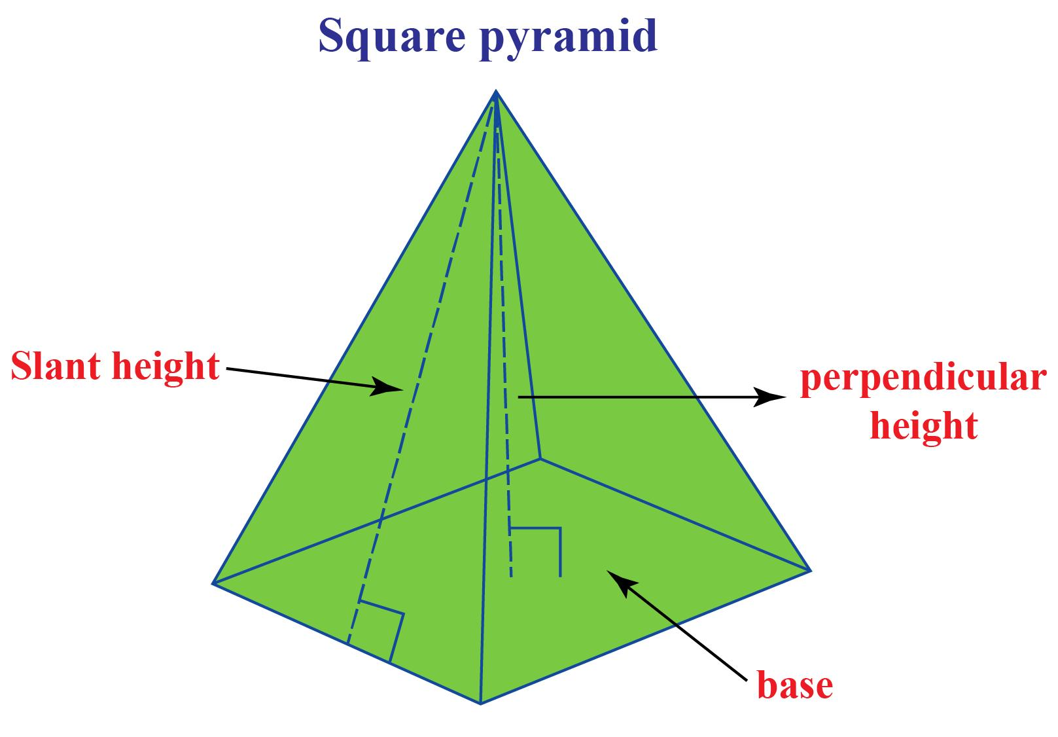

4. Cone
# Source: AI Source: Provided by: [Data Path: Persons Table -> ID Column: 1, Name_En Column: Motasem Essam] -> From: [ChatGPT] on [7/20/2026]
The height of a cone is the perpendicular distance from the apex to the plane containing the circular base.
$$\boxed{V=\frac{1}{3}πr^{2}h}$$
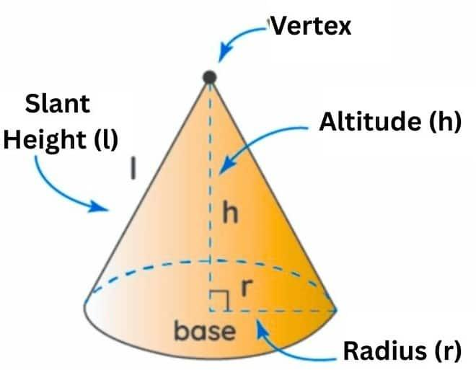
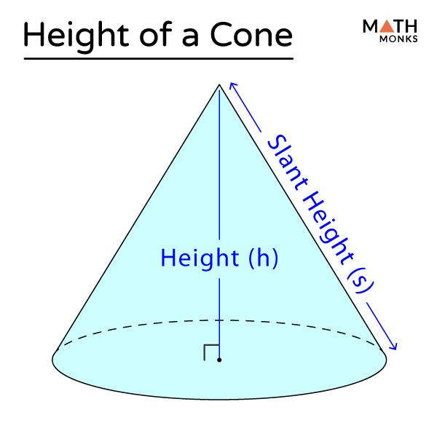
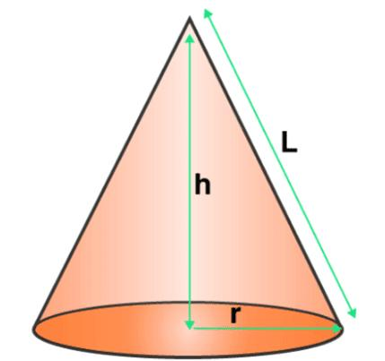
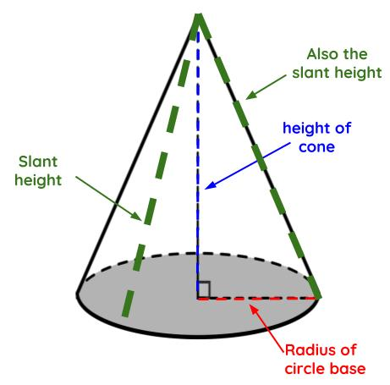

Height vs. Slant Height
# Source: AI Source: Provided by: [Data Path: Persons Table -> ID Column: 1, Name_En Column: Motasem Essam] -> From: [ChatGPT] on [7/20/2026]
This distinction is particularly important for cones and pyramids.
Perpendicular Height
$$\boxed{h⊥\text{Base}}$$
Slant Height
The slant height follows the inclined surface and is not perpendicular to the base.

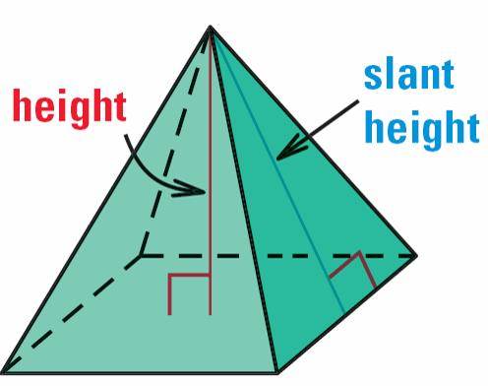

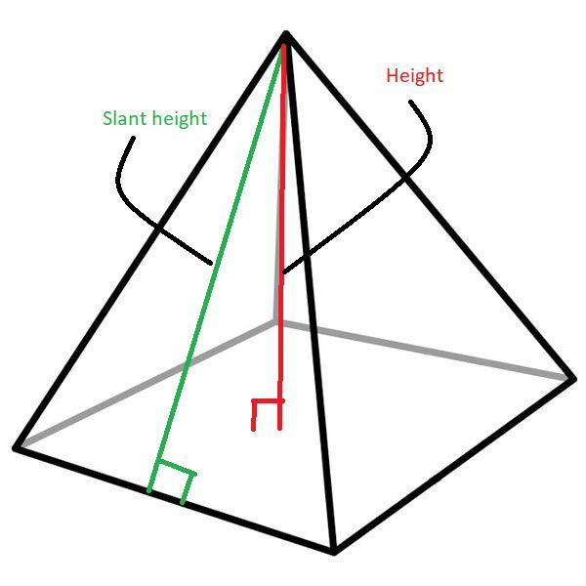
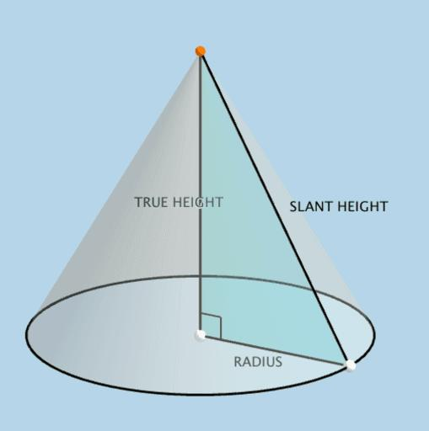
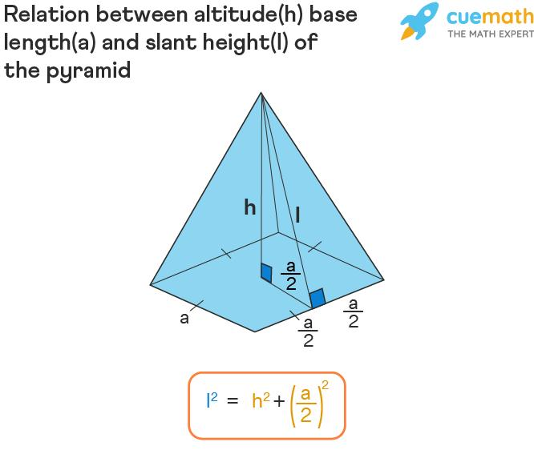
Therefore:
$$\boxed{\text{Height}≠\text{Slant Height}}$$
in general.

Height and Base Relationship
# Source: AI Source: Provided by: [Data Path: Persons Table -> ID Column: 1, Name_En Column: Motasem Essam] -> From: [ChatGPT] on [7/20/2026]
The base and height form a perpendicular relationship:
$$\boxed{\text{Base}⊥\text{Height}}$$
This relationship is fundamental to many formulas.
Triangle
$$A=\frac{1}{2}bh$$
Parallelogram
$$A=bh$$
Trapezoid
$$A=\frac{\left(b_{1}+b_{2}\right)h}{2}$$
Prism
$$V=Bh$$
Cylinder
$$V=πr^{2}h$$
Pyramid
$$V=\frac{1}{3}Bh$$
Cone
$$V=\frac{1}{3}πr^{2}h$$

Height vs. Length, Width, and Depth
# Source: AI Source: Provided by: [Data Path: Persons Table -> ID Column: 1, Name_En Column: Motasem Essam] -> From: [ChatGPT] on [7/20/2026]
In a three-dimensional object, height is one of the dimensions used to describe its spatial size.
For example, a rectangular prism can have:
[
$$\boxed{V=lwh}$$]
where:
- $l$ = length
- $w$ = width
- $h$ = height

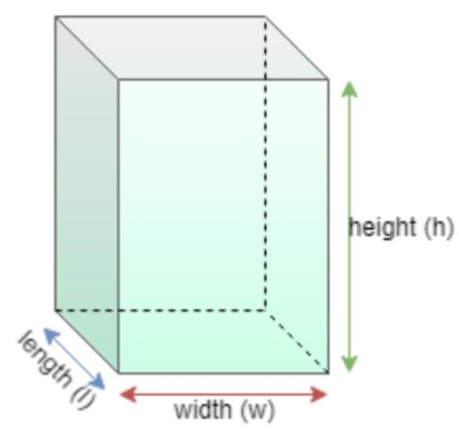
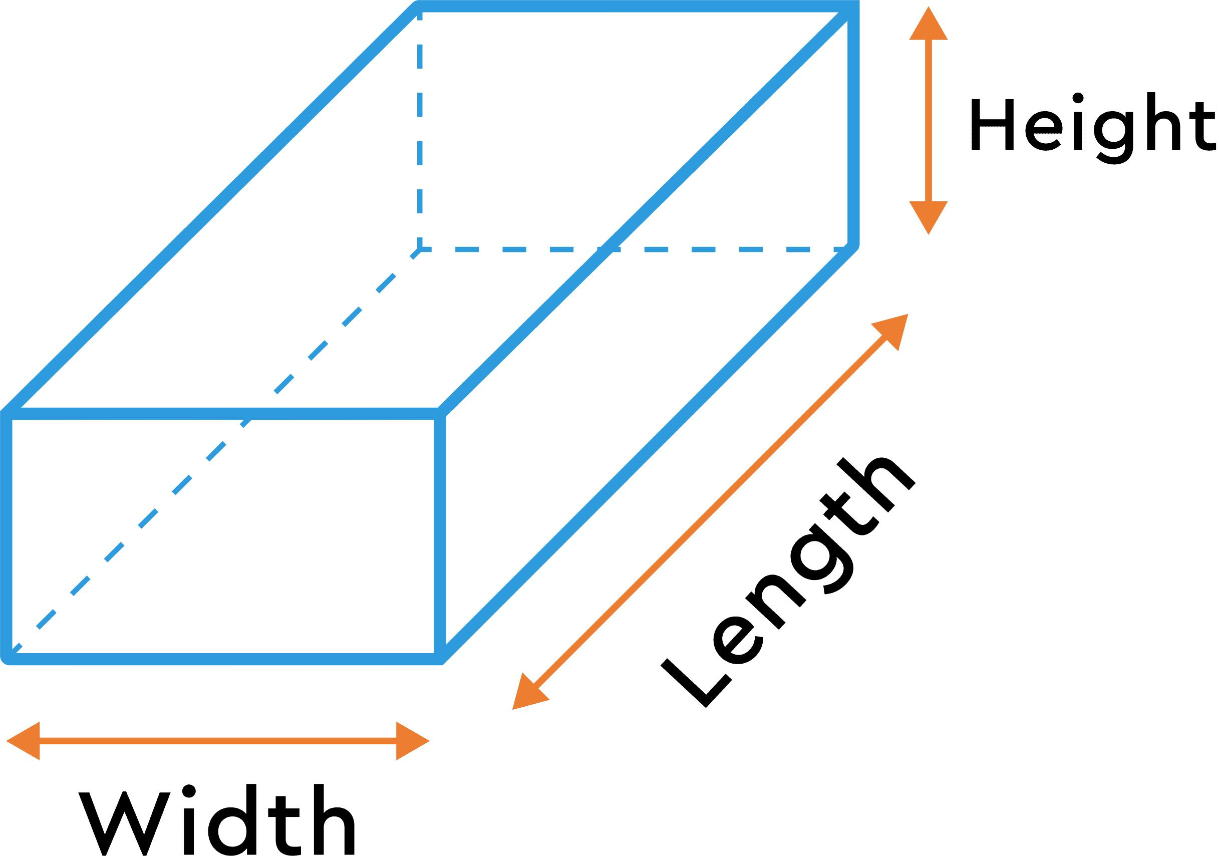
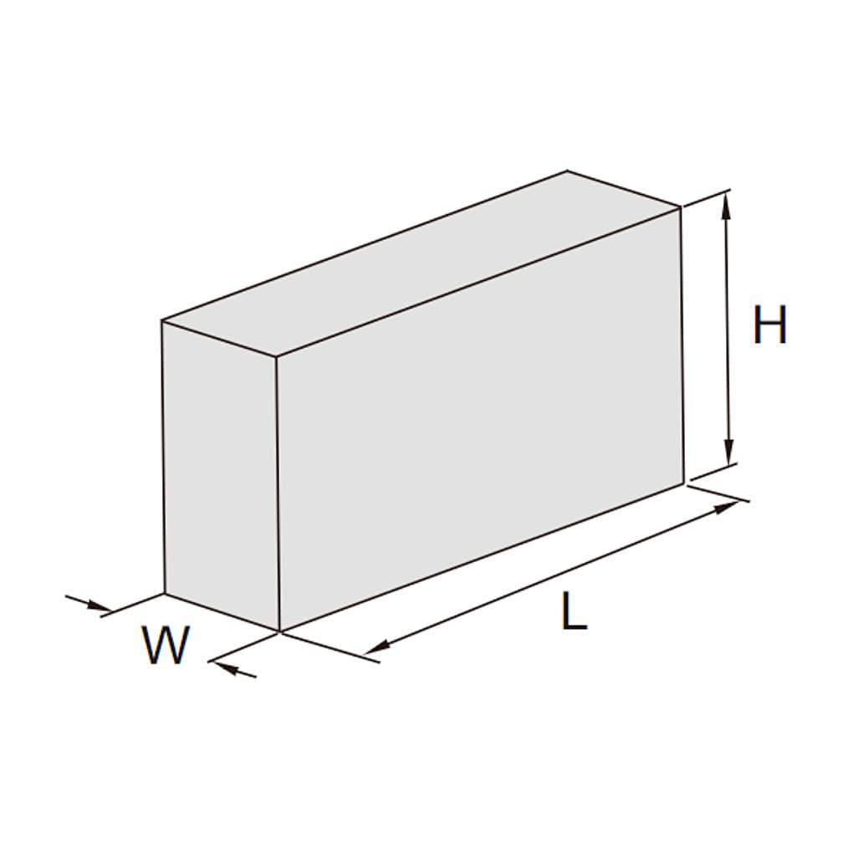
The exact choice of which dimension is called "height" can depend on how the object is oriented.

Important Mathematical Property
# Source: AI Source: Provided by: [Data Path: Persons Table -> ID Column: 1, Name_En Column: Motasem Essam] -> From: [ChatGPT] on [7/20/2026]
Height represents a distance, so it is always nonnegative:
$$\boxed{h≥0}$$
Its units are units of length, such as:
- millimeters (mm)
- centimeters (cm)
- meters (m)
- kilometers (km)
- inches (in)
- feet (ft)

Height as an Altitude
# Source: AI Source: Provided by: [Data Path: Persons Table -> ID Column: 1, Name_En Column: Motasem Essam] -> From: [ChatGPT] on [7/20/2026]
In triangle geometry, height is commonly called an altitude.
An altitude is a line segment drawn from a vertex perpendicular to the opposite side or its extension.
$$\boxed{\text{Altitude}=\text{Perpendicular Height}}$$
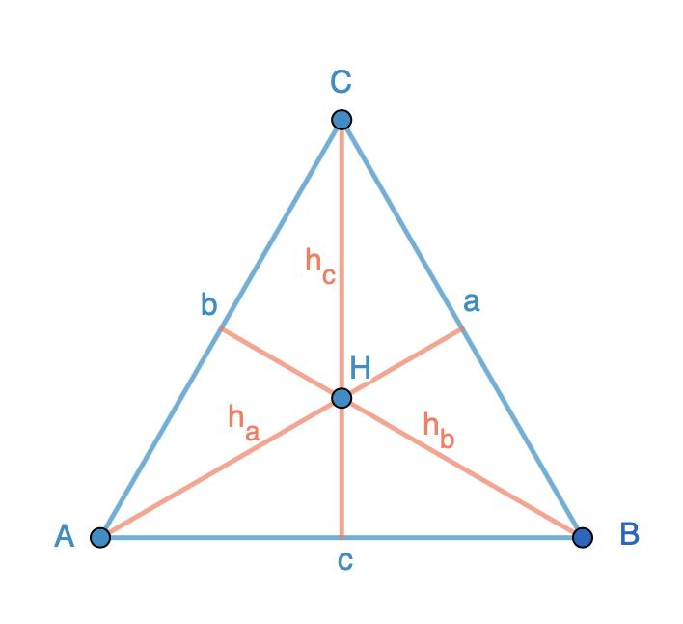
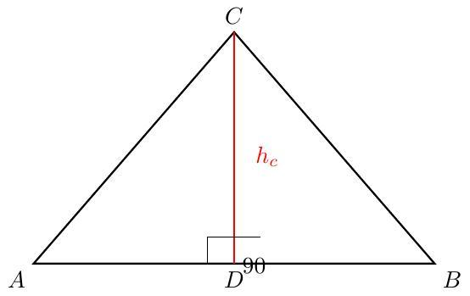
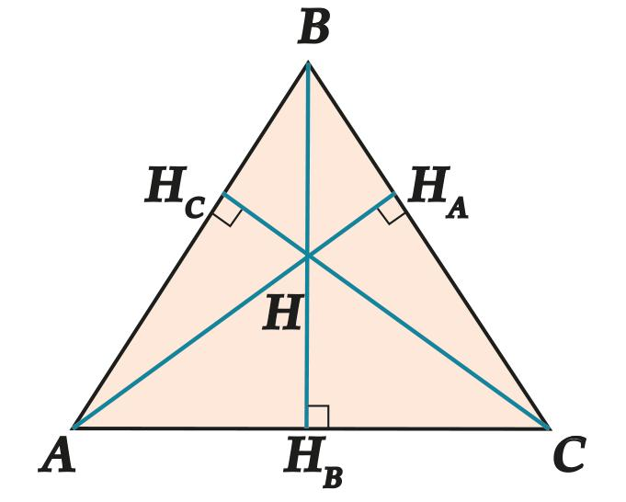
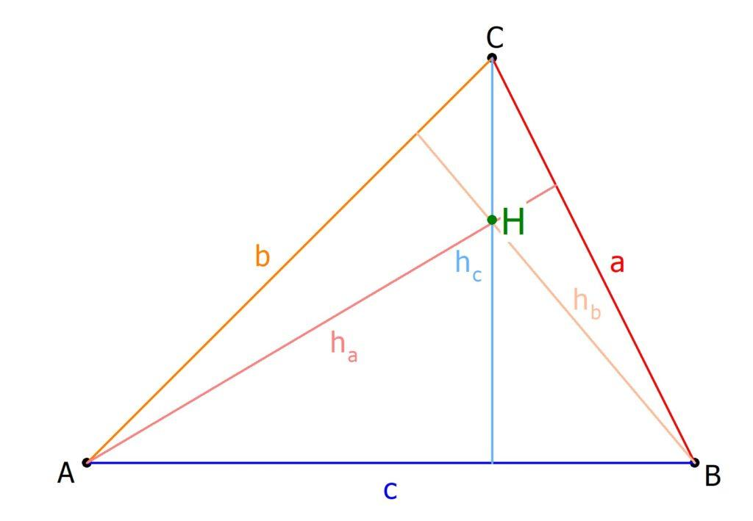
A triangle has three possible altitudes because each of its three sides can be selected as the base.

Applications
# Source: AI Source: Provided by: [Data Path: Persons Table -> ID Column: 1, Name_En Column: Motasem Essam] -> From: [ChatGPT] on [7/20/2026]
Height is important in:
- Geometry
- Measurement Theory
- Engineering
- Architecture
- Technical Drawing
- Mechanical Design
- Construction
- Manufacturing
- Robotics
- Computer Graphics
- CAD (Computer-Aided Design)
- Surveying
- Navigation

Advantages
# Source: AI Source: Provided by: [Data Path: Persons Table -> ID Column: 1, Name_En Column: Motasem Essam] -> From: [ChatGPT] on [7/20/2026]
Understanding height helps to:
- Describe the vertical dimension of objects.
- Measure perpendicular distances from a base.
- Calculate areas of triangles, parallelograms, and trapezoids.
- Calculate volumes of prisms, cylinders, pyramids, and cones.
- Define elevations and vertical positions.
- Support accurate engineering and architectural designs.
- Analyze geometric relationships and proportions.

Limitations
# Source: AI Source: Provided by: [Data Path: Persons Table -> ID Column: 1, Name_En Column: Motasem Essam] -> From: [ChatGPT] on [7/20/2026]
Height:
- Is a one-dimensional measurement.
- Usually requires a defined vertical or reference direction.
- Does not by itself describe the complete size of an object.
- May depend on the chosen orientation or base.
- Should not be confused with slant height.
- Does not describe area or volume by itself.

Key Points
# Source: AI Source: Provided by: [Data Path: Persons Table -> ID Column: 1, Name_En Column: Motasem Essam] -> From: [ChatGPT] on [7/20/2026]
$$\boxed{\text{Height}=\text{Perpendicular Distance}}$$
Height:
- Is a length measurement.
- Is measured at 90° to the base.
- Depends on the selected base or orientation.
- Is often represented by $h$.
- Is called an altitude in triangle geometry.
- Is fundamental to area and volume formulas.
- Should not be confused with slant height.
- Can be a distance between parallel lines or planes.

Conclusion
# Source: AI Source: Provided by: [Data Path: Persons Table -> ID Column: 1, Name_En Column: Motasem Essam] -> From: [ChatGPT] on [7/20/2026]
Height in geometry is the perpendicular distance associated with a chosen base. In plane figures, it commonly represents the perpendicular distance from a vertex to the opposite base line or the distance between parallel sides. In solid geometry, it represents the perpendicular distance between the base and the corresponding opposite surface or vertex. Height is fundamental to area, volume, altitude, and base–height relationships, and it should always be distinguished from a slanted or non-perpendicular length.

